

User Manual
CV12 Pro Chamber Vacuum Sealer
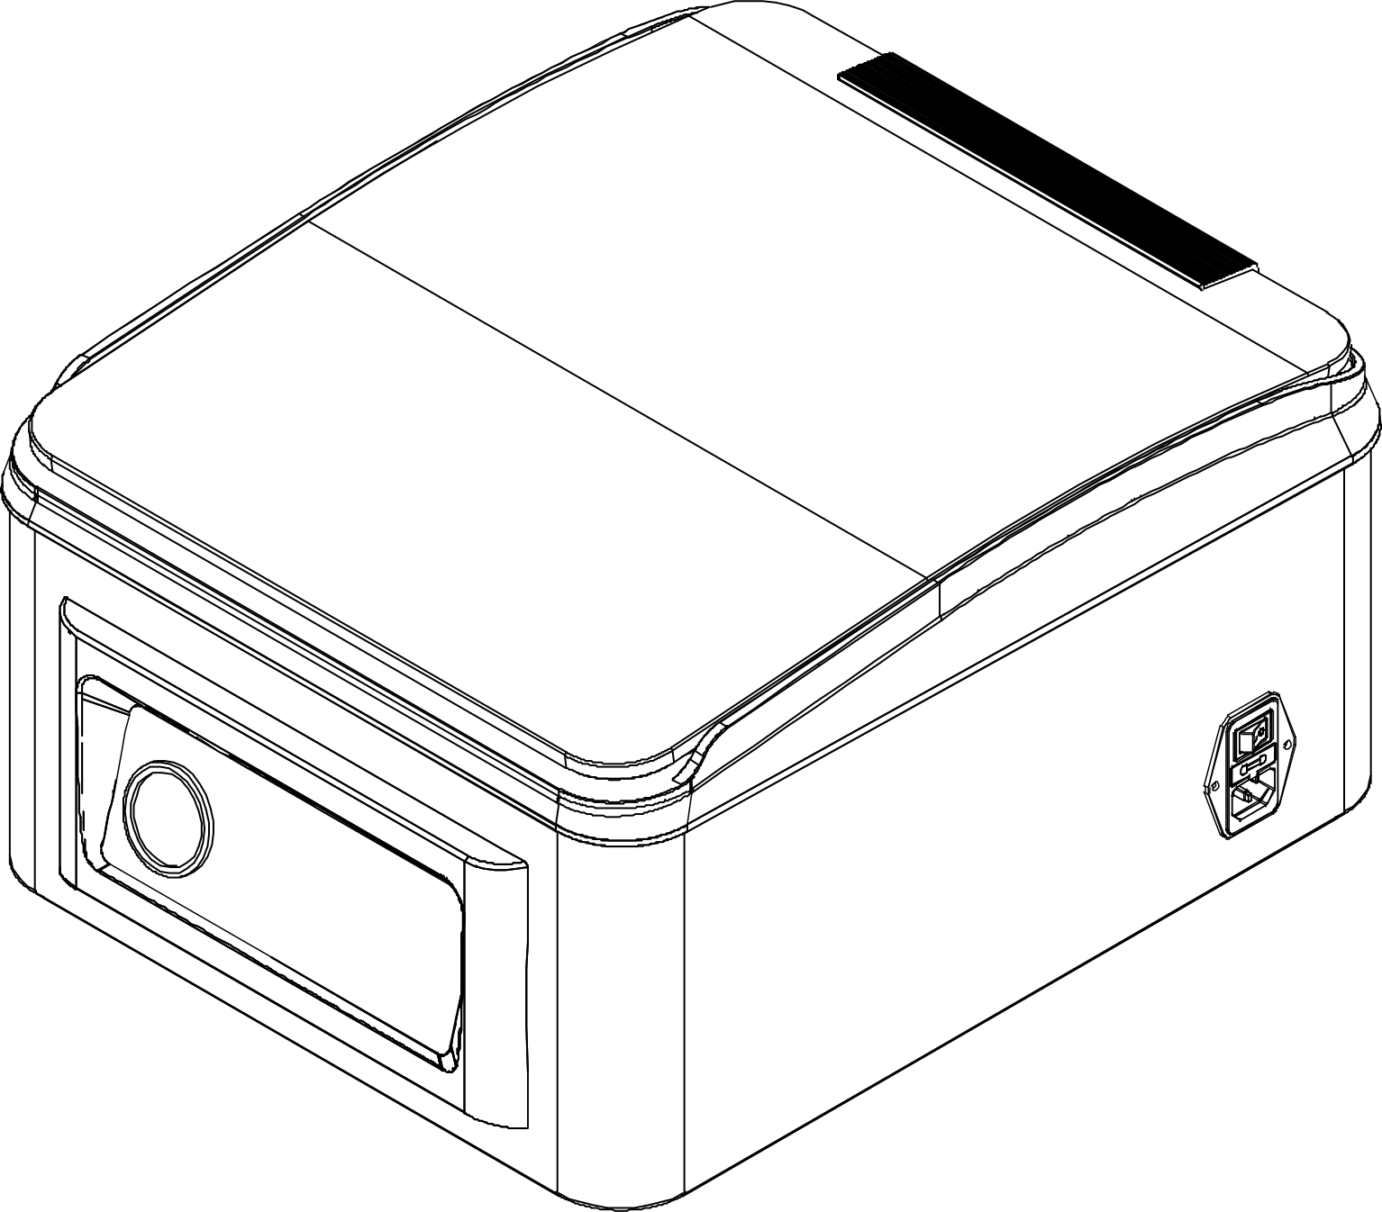

WEVAC TECHNOLOGY CO., LIMITED
wevactech.com
Table of Contents
Important Safety Information 3
Product Usage Guidelines 5
Product Components 7
Features and Options 8
Operating Instructions 10
General Information 10
Before You Begin… 10
Vacuum Sealing Bags 11
Sealing Bags 12
Using the Vacuum Hose 14
Vacuum Sealing Mason Jars 14
Vacuum Sealing Vacuum Canisters 15
Marinate Mode Instructions 15
Factory Reset 15
Auto Sleep 16
Maintenance 17
General Cleaning 17
Cleaning the Food Tray 17
Cleaning the Seal Bar 17
Troubleshooting 19
Cannot Operate 19
Cannot Vacuum Seal 19
Cannot Open the Lid After a Power Outage 19
Bag does not Hold a Vacuum 20
Error Codes 21
Technical Specifications 22
Vacuum Packaging Basics 23
Vacuum food storage reference 25

Important Safety Information

Before using this machine, please read all instructions in this manual carefully and always follow the safety precautions below.

- Only plug the appliance into a properly grounded electrical outlet. Do not use extension cords or modified power cables.
- To disconnect the appliance from the power supply, always unplug it directly from the wall outlet. Do not pull on the power cord.
- Do not operate the appliance if the power cord is damaged.
- Never immerse the appliance or the power cord in water.
- This appliance is not a toy. Children and persons with reduced physical, sensory, or mental capabilities must use this product only under supervision and with proper guidance to ensure safety.
- Never place sealed Mason jars inside the vacuum chamber for vacuuming. The negative pressure inside the chamber may cause glass jars to shatter. Always use the supplied vacuum hose and Mason jar adapter and connect them to the external vacuum port.
- Do not strike or place heavy objects on the vacuum lid. Avoid impact or pressure that may damage the lid.
- Keep the machine in an upright position during movement or transportation. Tilting the unit may cause damage.
- During operation, do not touch the vacuum lid, vacuum chamber, or seal bar to avoid injury, burns, or damage to the appliance.
- Maintain a minimum distance of 4 inches (10 cm) between the appliance and walls or other objects to ensure proper ventilation and heat dissipation.
- Do not use the appliance in environments containing flammable or explosive gases. Keep the appliance away from heat sources or steam-generating equipment, such as steamers, dishwashers, or stoves.
- If the machine is damaged due to improper use or failure to follow the instructions in this manual, the dealer or supplier will not be responsible for warranty service.
- Do not dispose of this product with household waste. Please recycle or dispose of it in accordance with all applicable electronic waste regulations in your region.
- This product is for indoor use only.

Product Usage Guidelines
- This machine is compatible with both flat bags and textured bags. Flat bags are more cost-effective while providing comparable performance to textured bags.
- For items with sharp points or edges, wrap the corners with soft materials such as puncture-resistant sheets or paper towels to prevent puncturing the vacuum bag.
- Vacuum bags can be used for heating or microwave heating. A small vent hole must be cut in the corner of the bag beforehand.
- Vacuum bags used for storage can be reused. However, bags used for heating or microwaving should be used only once. Bags that have stored raw fish or oily foods are not recommended for reuse.
- When placing the bag inside the chamber, ensure the opening lies flat across the seal bar and the underside of the bag is inserted under the bag clamp. This ensures proper airflow during vacuuming.
- Leave at least 2 inches (5 cm) of space between the bag opening and the food to prevent liquids from overflowing and contaminating the seal during vacuuming.
- Under vacuum, the boiling point of liquids decreases significantly. Hot soups may bubble vigorously and overflow the bag. Always cool hot liquids or sauces to room temperature or lower before vacuum sealing. If large bubbles appear during vacuuming (appearing to boil), this is a normal physical phenomenon. Immediately press the “Stop” and “Seal” buttons to stop vacuuming and seal the bag to prevent overflow.
- When vacuuming liquids, sauces, or foods containing liquids or sauces, avoid wetting the bag opening. It is recommended to dry the bag opening after filling to ensure proper sealing.
- Soft, high-moisture foods or foods that need to maintain their shape achieve the best results when frozen before vacuum sealing.
- Do not place items higher than the bottom edge of the sealing gasket in the vacuum chamber, as this may damage the machine.
- Do not place heavy objects on the vacuum lid, as this may cause damage.
- During operation, do not strike or force open the vacuum lid.
- The seal bar is a precision component; handle with care. Dropping it may cause damage.
- Rinse the seal bar only. Do not immerse the seal bar when cleaning.

Product Components
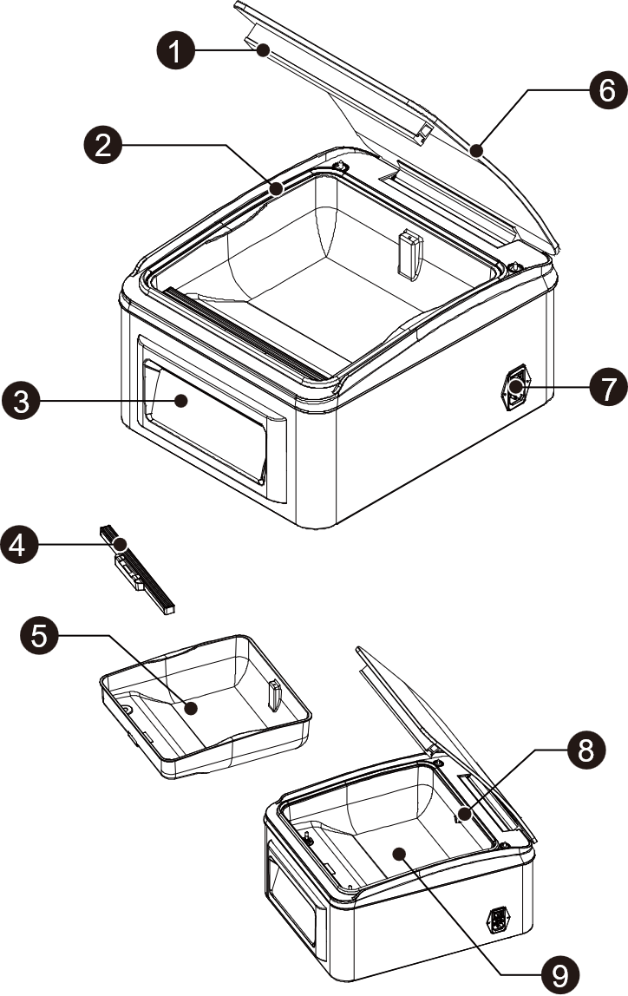

1 | Seal pad | 6 | Lid
2 | Sealing gasket | 7 | Power cord socket
3 | Control panel & pressure gauge | 8 | Vacuum port
4 | Seal bar & bag clamp | 9 | Vacuum chamber
5 | Removable food tray

Features and Options

Control Panel
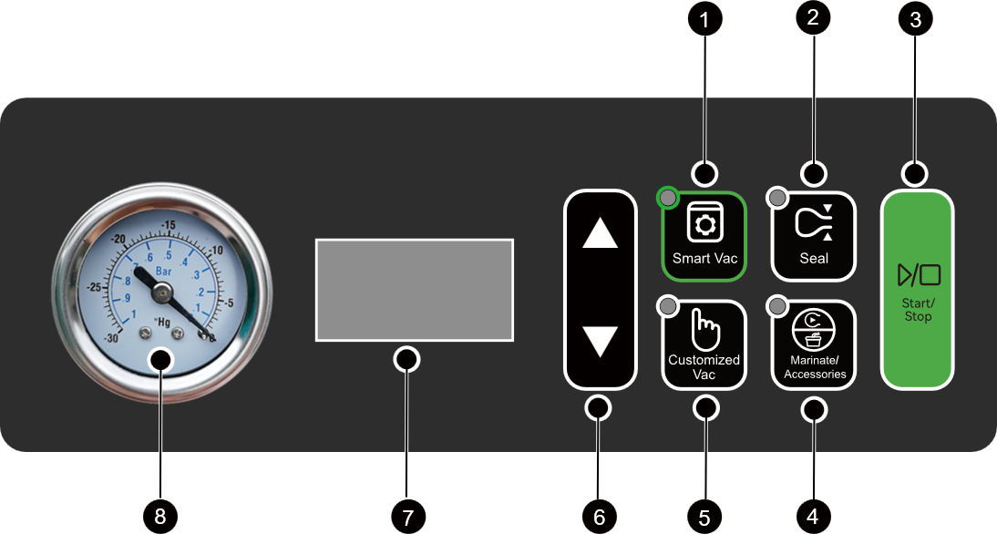

- Smart Vac button
  - Innovative intelligent vacuum mode. In this mode, the machine automatically sets the vacuum time without the need for manual adjustments or experience-based timing.
  - This mode is selected by default when the machine is powered on.
- Seal button
  - Seal mode. Press this button to immediately seal a bag (including material cut from rolls).
  - Press this button in combination with the “▲/▼” buttons to adjust the sealing time (0–9 seconds). The machine will automatically save the settings.
- Start / Stop button
  - Starts or stops the currently selected function.
- Marinate / Accessories button
  - Marinate / Accessory mode. This mode enables vacuum marinating of food inside the chamber, or vacuum sealing of external accessories, such as jars, canisters, and bottles, using the vacuum hose.
- Customized Vac button
- Customized vacuum mode. In this mode, you can manually set the vacuum time according to your needs.
- ▲/▼ button
  - Use the “▲” or “▼” buttons to increase or decrease the sealing time, adjust the vacuum time in customized vacuum mode, or set the time in marinate mode. Press and hold to adjust quickly.
  - In customized vacuum mode: 5–80 seconds
  - In marinate mode: 6–60 minutes
  - Sealing time adjustable range: 0–9 seconds
- Digital display
The digital display provides the following information:
  - Displays the selected function mode, including Smart Vac“  ”, Accessories mode “  ”, etc.
  - Shows the set time or the elapsed time during operation.
  - Displays machine error codes.
- Pressure gauge
  - Displays real-time vacuum pressure.

Operating Instructions

General Information
- To ensure optimal sealing performance, it is recommended to wait 20 seconds between consecutive seals.
- If the lid cannot be opened due to a power outage, the machine will automatically release pressure once power is restored. After the pressure is released, the lid can be opened.
- When using vacuum jars, Mason jars, or other modes that require the vacuum hose, keep the lid open before starting the operation.
- When using Smart Vac, Customized Vac, Marinate, or Seal-only modes, close the lid before starting. Pressing the Start / Stop button with the lid open will trigger a beep; in this case, close the lid before proceeding.

Before You Begin…
  - Plug the power cord into the machine’s side power socket and the wall outlet.
  - The machine will beep, the control panel will illuminate, and the display will show “”. The machine is now in standby mode and ready for use.
  - Select an appropriately sized vacuum bag and place the items inside. Leave at least 2 inches (5 cm) of space between the items and the bag opening.
  - Lay the vacuum bag flat on the sealing strip and insert the bottom edge into the bag clamp.
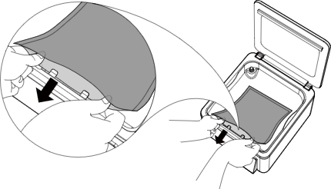
  - When vacuuming a bag, always place it following this method.

Vacuum Sealing Bags
- Smart Vac Mode
The Smart Vac mode automatically adjusts the vacuum time based on the volume of the food, achieving optimal sealing without manual settings.
- Place the vacuum bag correctly in the vacuum chamber.
- Close the lid.
- Press the Start / Stop button. The machine will automatically complete the vacuum sealing process.
- To interrupt the vacuum process and immediately start sealing, press the Seal button.
  - Smart Vac Pressure Adjustment
The Smart Vac mode is an intelligent program based on a preset vacuum pressure level. The default pressure level is suitable for vacuum sealing most items available on the market.
If you have special requirements, you can adjust the Smart Vac pressure level. This adjustment changes the vacuum time accordingly, effectively increasing or decreasing the vacuum pressure.
- In standby mode, press the Smart Vac button. The display will show “  ”.
- Press and hold the Smart Vac button for 3 seconds to enter Smart Vac time adjustment.
- To increase the Smart Vac pressure, press the ▲ button to increase the time.
- To decrease the Smart Vac pressure for faster operation, press the ▼ button to reduce the time.
- Adjustment range: -20 seconds to +20 seconds.
- After adjustment, press the Smart Vac button or the Stop button to exit and save the settings. If no operation is performed within 5 seconds, the machine will automatically exit the setting mode.
  - Customized Vac Mode
If the Smart Vac mode does not meet your specific needs, you can use the Customized Vac mode to manually adjust the vacuum time.
- Press the Customized Vac button.
- Use the ▲ / ▼ buttons to adjust the vacuum time.
- Close the lid and press the Start / Stop button to begin the vacuuming and sealing process.

Sealing Bags
The Seal option allows you to create bags from rolls or simply seal items without a vacuum. The default seal time is 4 seconds.
  - Seal-Only Operation
- Place the item into the bag and the bag into the chamber with the lower side under the bag clips.
- Select Seal mode by pressing the Seal button. The display will show the current seal time.
- Use the ▲ / ▼ buttons to adjust the seal time, if desired. The set seal time applies to Smart Vac sealing, Customized Vac sealing, and Seal-only operations.
- Close the lid, press the Start / Stop button, and the machine will seal the vacuum bag.
- Creating a Bag from a Roll
- Cut a suitable length of vacuum bag material from the roll. Ensure a minimum of 2 inches (5 cm) of head space.
- Place one end of the cut material flat on the seal bar with the lower side under the bag clips, with the remaining part of the bag inside the vacuum chamber.
- Press the Seal button to enable Seal mode, close the lid, and press the Start / Stop button to begin the sealing process.
- When the sealing time ends, the machine will beep three times to indicate completion.
- Open the lid and check the seal quality.
Note： When checking the seal quality, a proper seal should appear transparent. If the seal shows spots or incomplete sealing, increase the seal time. If the seal appears white, milky, or shows burning, reduce the seal time.

Using the Vacuum Hose
  - Connect hose port ③ to the vacuum port inside the vacuum chamber.

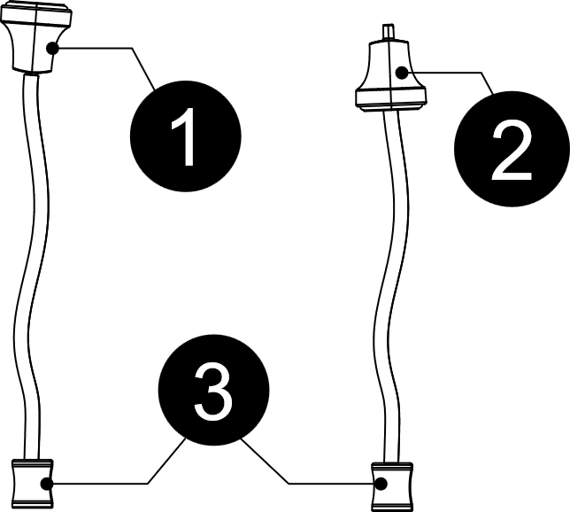
  - When vacuuming Mason jars with adapters or valve zipper bags, use nozzle orientation ①.
  - When vacuuming vacuum jars or stoppers, choose nozzle orientation ① or ② according to the size of the vacuum port.

Vacuum Sealing Mason Jars
  - Place the lid on the mouth of the jar without the retaining ring.
  - Attach the Mason jar adapter over the mouth and lid.
  - Connect the vacuum hose: one end to the vacuum port inside the chamber, the other end to the Mason jar adapter.
  - Press the Marinate / Accessories button to select Accessory mode.
  - Press the Start / Stop button to begin vacuuming the Mason jar.
  - After completion, disconnect the vacuum hose and remove the Mason jar adapter.
  - Screw on the retaining ring to secure the lid.

Vacuum Sealing Vacuum Canisters
  - Connect the vacuum hose to the vacuum port inside the chamber.
  - Ensure the vacuum canister is in a Vacuum-ready state. Connect the vacuum hose to the jar following the Using the Vacuum Hose section.
  - Press the Marinate / Accessories button to select Accessory mode.
  - Press the Start / Stop button to begin vacuuming.
  - After the vacuum process is complete, disconnect the vacuum hose.

Marinate Mode Instructions
  - There are two typical ways to use the Marinate mode.
- Marinating inside the vacuum chamber: Place the food in a container or vacuum bag of appropriate height, keep the opening exposed, and close the vacuum lid.
- Marinating outside the vacuum chamber: Connect the vacuum port inside the chamber to a suitable vacuum container (or bag) holding the food via the vacuum hose. Keep the vacuum lid open.
  - Press the Marinate / Accessories button to select Marinate mode. The display will show the marinate time, with a default setting of 18 minutes (3 cycles). Use the ▲ / ▼ buttons to adjust the time (cycles) as needed.
  - Press the Start / Stop button to begin vacuum marination. The digital display will first show the applied pressure; once the target pressure is reached, it will show the remaining time.
  - When the display shows 0, the marination process is complete.

Factory Reset
  - After each power-on, all function parameters will default to the last user settings. To restore factory settings, follow these steps:
In standby mode, press the Smart Vac button. The display will show “ ”. Then press and hold the ▲ button for 5 seconds until the display shows “” (Reset). The machine will now restore all settings to the factory defaults while in standby mode.

Auto Sleep
  - When the machine is powered on, if no operation is performed for 30 minutes, it will automatically enter sleep mode.
  - In sleep mode, the button indicators will turn off and the digital display will show OFF.
  - Press any button to exit sleep mode.

Maintenance

General Cleaning
- Always unplug the appliance from the power supply before cleaning or performing maintenance.
- Do not use abrasive cleaners or scouring pads, as they may scratch the surface.
- Clean with a soft damp cloth, sponge, or kitchen paper. Mild dish soap or soapy water may be used if necessary.

Cleaning the Food Tray
- Rinse or soak the tray in water. For stubborn stains, use a mild detergent with a cloth.
- It is recommended to use a neutral pH detergent.
- Do not use stiff-bristled brushes to avoid damage.
- The tray is not dishwasher safe.

Cleaning the Seal Bar
After use, the seal bar will be hot. Wait at least 5 minutes for it to cool before performing any cleaning to prevent burns.
- The seal bar can be washed with water but is not dishwasher safe. Do not place it in a dishwasher.
- Clean the seal bar by rinsing with tap water or wiping with a soft cloth. Do not use stiff brushes, as this may damage the high-temperature tape. Damaged tape may cause seal bar malfunction.
- If necessary, a neutral pH detergent may be used. Rinse thoroughly to remove any detergent residue.
- After cleaning, dry the seal bar surface with a soft cloth. Ensure that the two holes at the bottom are not blocked after cleaning.
Note: If the seal bar is visibly damaged or the high-temperature tape is compromised, the sealing performance may be affected. Replace with a new seal bar if needed.

Troubleshooting
Your vacuum sealer is designed for long-term, reliable operation under normal use. However, issues may occasionally arise. Please consult the following sections for common troubleshooting tips and error code explanations.

Cannot Operate
- Ensure the unit is securely plugged into a power outlet.
- Inspect the power cord for damage. If the cord is frayed or damaged, replace it immediately or contact customer support.

Cannot Vacuum Seal
- The vacuum or sealing time may be set too short. Extend the vacuum or sealing time and try again.
- Check whether the vacuum bag is positioned correctly inside the vacuum chamber, including but not limited to the following:
- Ensure the bag clamp is used correctly to keep the bag opening fully open.
- Make sure the bag opening is clean, dry, flat, and free of wrinkles.
- Check the sealing gasket for displacement, deformation, improper installation, or contamination.
- Check whether the seal pad is installed correctly or is damaged.
- Inspect the vacuum bag for leaks. If any leakage is detected, replace the bag with a new one.

Cannot Open the Lid After a Power Outage
- Once power is restored, the lid can be opened normally.
- If power cannot be restored for a long time, ask a qualified technician to disconnect the hose from the vacuum gauge to open the lid.

Bag does not Hold a Vacuum
- If the vacuum bag loses its seal after vacuuming, the seal may be compromised by wrinkles, moisture, food residue, or sharp objects. Remove the existing seal, clean and dry the bag opening, remove any sharp objects, and vacuum seal again.
- If there is liquid at the sealing area or the food has high moisture content, wipe the bag opening dry first. For best results, freeze the food before vacuum sealing.
- If the bag is damaged or has pinholes, replace it with a new vacuum bag before sealing again.
- If the sealing temperature is insufficient (incomplete seal) or excessive (seal is melted or burned through), cut off the affected seal area, increase or decrease the sealing time accordingly, and vacuum seal again.

Error Codes
Error Codes | Reason | Solution
 | Vacuum Not Reached Within 10 Seconds | If the machine fails to reach the specified vacuum level within 10 seconds after closing the vacuum lid and starting operation:  - Press the “Stop” button to exit the error state.  - Check whether the vacuum chamber gasket is installed correctly and try again.  - Inspect the vacuum chamber gasket for damage or food debris. If dirty, clean it with a soft cloth and gently dry. If damaged, contact customer service to replace it.  - If the error persists, contact customer service for assistance.
 | Lid Not Fully Closed at Start of Sealing | - Ensure the lid is fully closed.  - Check the gasket for damage or food debris. If dirty, clean it with a soft cloth and gently dry. If damaged, contact customer service for assistance.  - If the error continues, contact customer service for assistance.

Technical Specifications

Model | CV12 Pro
Power supply | 120V~ 60Hz
Power | 360W
Pressure | -999 mbar （-29.5 inHg）
Pump flow rate | 85 L(5，187in³) / min
Maximum seal width | 305 mm （12 in）
Seal wire width | 2×2.5 mm （2×0.1 in）
Dimensions | 368×455×244 mm （14.5×17.9×9.6 in）

Vacuum Packaging Basics
Vacuum packaging extends the shelf life of food by removing most of the air from sealed containers, preventing fresh air from entering and reducing oxidation. This helps preserve the flavor and overall quality of the food. Additionally, it inhibits the growth of aerobic microorganisms, which can lead to the following issues under certain conditions:
Mold – Mold cannot grow in a low-oxygen environment, so vacuum packaging can effectively eliminate it.
Yeast – Yeast causes fermentation, which can be identified by smell and taste. It requires water, sugar, and moderate temperatures to grow and can survive with or without air. Refrigeration slows yeast growth, while freezing halts it completely.
Bacteria – Bacteria cause unpleasant odors, discoloration, and/or soft or slimy textures. Under the right conditions, Clostridium botulinum (the bacterium that causes botulism) can grow in the absence of air and cannot be detected by smell or taste. While extremely rare, botulism can be very dangerous.
As with any other storage method, it is important to inspect food for spoilage before consuming it.
To preserve food safely, it is crucial to maintain low temperatures. The growth of microorganisms can be significantly slowed at temperatures of 39ºF (4ºC) or below. For long-term storage, always freeze perishable foods that have been vacuum packaged. It is important to note that vacuum packaging cannot reverse food deterioration; it only slows changes in quality. The length of time food will retain its optimal flavor, appearance, and texture depends on the age and condition of the food when it was vacuum packaged.
Note: Vacuum packaging is not a substitute for refrigeration or freezing. Any perishable foods that require refrigeration must still be refrigerated or frozen after vacuum packaging.

Storage Guidelines
Vegetables should be blanched before vacuum sealing. Blanching stops enzyme activity. After blanching, immerse the vegetables in cold water. Before vacuum sealing, thoroughly dry the vegetables with kitchen paper.
Cruciferous vegetables (such as broccoli, Brussels sprouts, cabbage, cauliflower, kale, and radish) naturally release gases during storage. Therefore, after vacuum sealing, it is recommended to store them in the refrigerator.

Not all foods are suitable for vacuum sealing!
Do not vacuum seal garlic, mushrooms, or other fungi.
In a low-oxygen environment, these foods may promote the growth of harmful microorganisms and may pose serious health risks if consumed.

Vacuum food storage reference
Storage | Foods | Typical  Storage | Vacuum  Packaging
Frozen | Meat | 6 months | 15-20 months
 | Fish, Seafood | 6 months | 10-12 months
 | Dried fruit,  Coffee beans | 6-9 months | 18-24 months
Refrigerated | Meat | 2-3 days | 12-13 days
 | Fish, Seafood | 2-3 days | 6-8 days
 | Cooked meat | 2-3 days | 10-14 days
 | Eggs | 2-3 days | 30-50 days
 | Vegetables | 2-3 days | 7-10 days
Dry | Bread | 1-2 days | 6-8 days
 | Cookies | 4-6 months | 12 months
 | Noodles | 5-6 months | 12 months
 | Rice | 5-6 months | 12 months
 | Flour | 4-5 months | 12 months
 | Crackers | 3-4 months | 12 months
 | Coffee | 2-3 months | 12 months
 | Tea | 5-6 months | 12 months
 | Powdered Milk | 1-2 months | 12 months

Thank you for purchasing a CV12 Pro Chamber Vacuum Sealer.
Enjoy using your new machine!

